

* There should be an actual photo of the master plan. Bachir’s team is working on an updated master plan as the previous one is no longer valid. We will share it whenever it is ready.
* You might consider having an interactive master plan, whereby the different projects are highlighted and clickable, or the different sectors.
* Construction progress is currently not clickable. The information should be updated by the Al Zorah team.
* The clickable neighborhoods below the master plan should redirect to the relevant sector page under Neighborhoods.
* You might want to include a key plan highlighting each neighborhood so that the website visitors can locate it in the bigger scheme of Al Zorah.



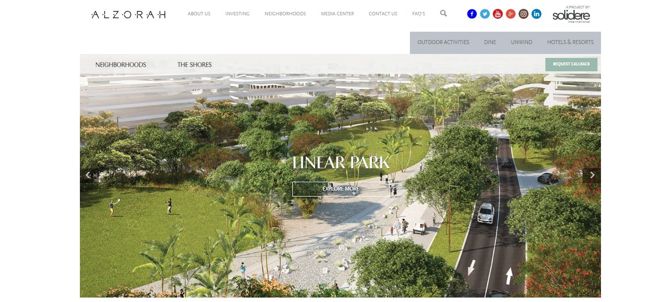

* This banner depicting the linear park should be changed to a real live photo. We can share the one we will use once approved.

# Under Neighborhoods – The Shores



* The text should be updated as per the attached file Neighborhoods Sectors Descriptions.



* The Oberoi is correct
* LUX* Resort is currently Resort 2. Visual and description not final yet.
* Al Zorah linear park, should replace renders with actual photo.



* The above photo should be: HOTEL BUILDING AND SWIMMING POOL (not Lobby)



* We will update you with photo and text as soon as we have something final.

# Under Neighborhoods – The Fairways



* The text for the above should be about the whole Fairways neighborhood and not only about the golf. Please use the text about the Fairways in the attached file Neighborhoods Sectors Descriptions.
* I suggest choosing a different photo. This one is stock image and it does not depict the fairways.
* Instead of 18-HOLE GOLF COURSE suggest using INSPIRATION AT YOUR DOORSTEP or SPECTACULAR GREEN BACKDROP.



* I would suggest placing Golf Club first as it comprises the largest area of the neighborhood and is the main attraction.
* Salim please confirm if the Pavilion is part of the Fairways or the Gates
* WELLNESS CENTER has a name now: ZOYA HEALTH AND WELLBEING RESORT (text attached)



* Attached is an updated text about the Golf Course
* In the above, there are many repetitions. The wider text (not needed) and then the text near the photo are repetitive.



* No need to mention phases anymore. Suggest text here to be:

Reside in a truly picturesque setting, with views of the mangrove forest, lakes, and the championship golf course on your doorstep. To live here is to choose a more relaxed way of living —closer to nature.



* Again the last wider paragraph is redundant. Suggest removing it.



* Salim to confirm that the above still applies or should be removed since third parties are developing the remaining villas.



• Again the last wider paragraph is redundant. Suggest removing it.



* Salim to confirm that the above still applies or should be removed since third parties are developing the remaining villas.



* Salim to confirm if we keep the Pavilion under the Fairways neighborhood or we move to the Gates
* Text on this page is too long and is repeated in Discover moe, suggest to reduce it here to:

Overlooking the golf course and the mangrove forest, the Pavilion invites visitors to a foretaste of the destination.



* Updated text in attached file



* Thanani is now called Nayana. Salim to advise if the description is still the same.



* New renderings and text will be shared as soon as possible.



* New text in attached file.
* New photo will be sent as soon as approved for the publication